Project Information

Project Name: TeamUp - Team Formation Platform
Repo: https://github.com/aminelfc96/TeamUp-Final
Student: Oussama Nasr eddine Bendjelloul
Student ID: 59652
Course: Team Project IT
Semester: 5th Semester
Project Type: Individual (Originally started as team project)
Reason: Two teammates left due to semester eligibility requirements

GroupUp Project Overview
What is GroupUp?
GroupUp is a web application that helps students connect and collaborate with peers studying the same courses or subjects. Users can search for, join, or create study groups, coordinate study sessions, and communicate with group members. The platform aims to promote collaborative learning, improve academic performance, and make studying more organized and social.
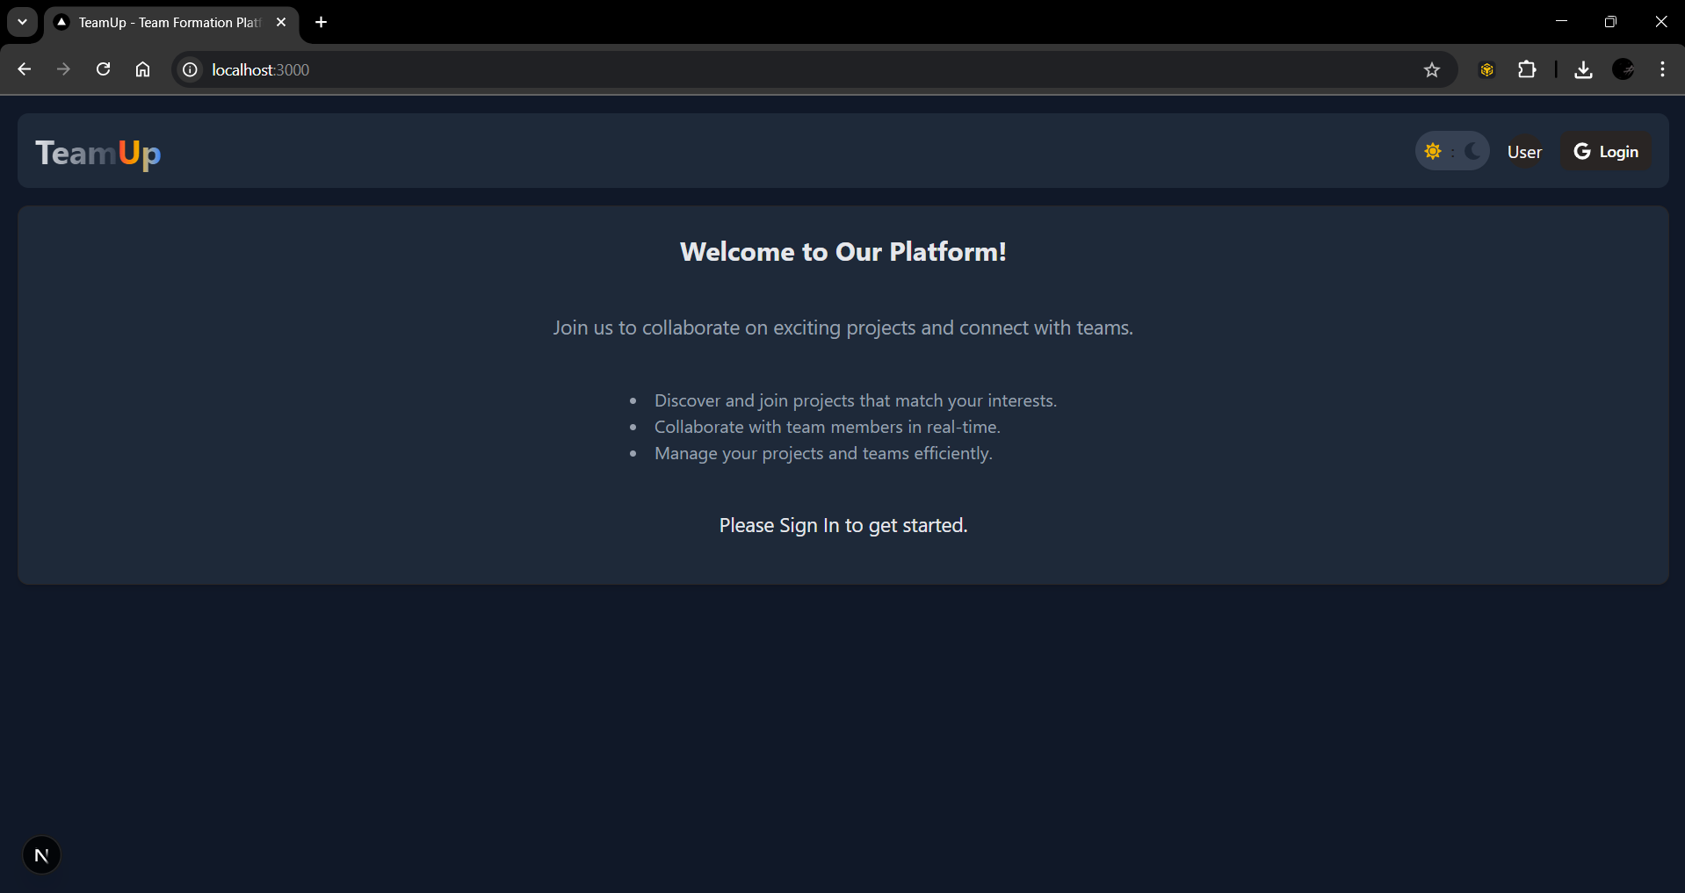
The Problem It Solves
Current Issues with Team Formation:
- Students waste time sending emails and messages to find teammates
- Random team selection often creates unbalanced groups
- Communication happens across different apps (WhatsApp, email, Discord)
- Shy students have difficulty asking others to join their team
- No clear way to see what skills other students have
- Project requirements are often unclear during team formation
GroupUp Solutions:
- Quick team formation in one organized place
- Students can see project requirements before joining
- All communication happens within the platform
- Easy system for students to request joining teams
- Clear overview of available projects and team needs
How TeamUp Helps Students
Time Saving: Instead of hours of messaging and coordination, team formation takes minutes
Better Matches: Students can choose projects that match their interests and skills
Clear Communication: All information about projects and teams is in one place
Inclusive Process: Students who are shy or new can easily participate in team formation
Organized System: No more confusion about who is in which team or what the project requirements are
Current Stage of Development
Fully Working Features:
- User authentication with Google accounts.
- Project creation and management.
- Team formation.
- User profiles and project browsing.
- Responsive design for computers and phones.
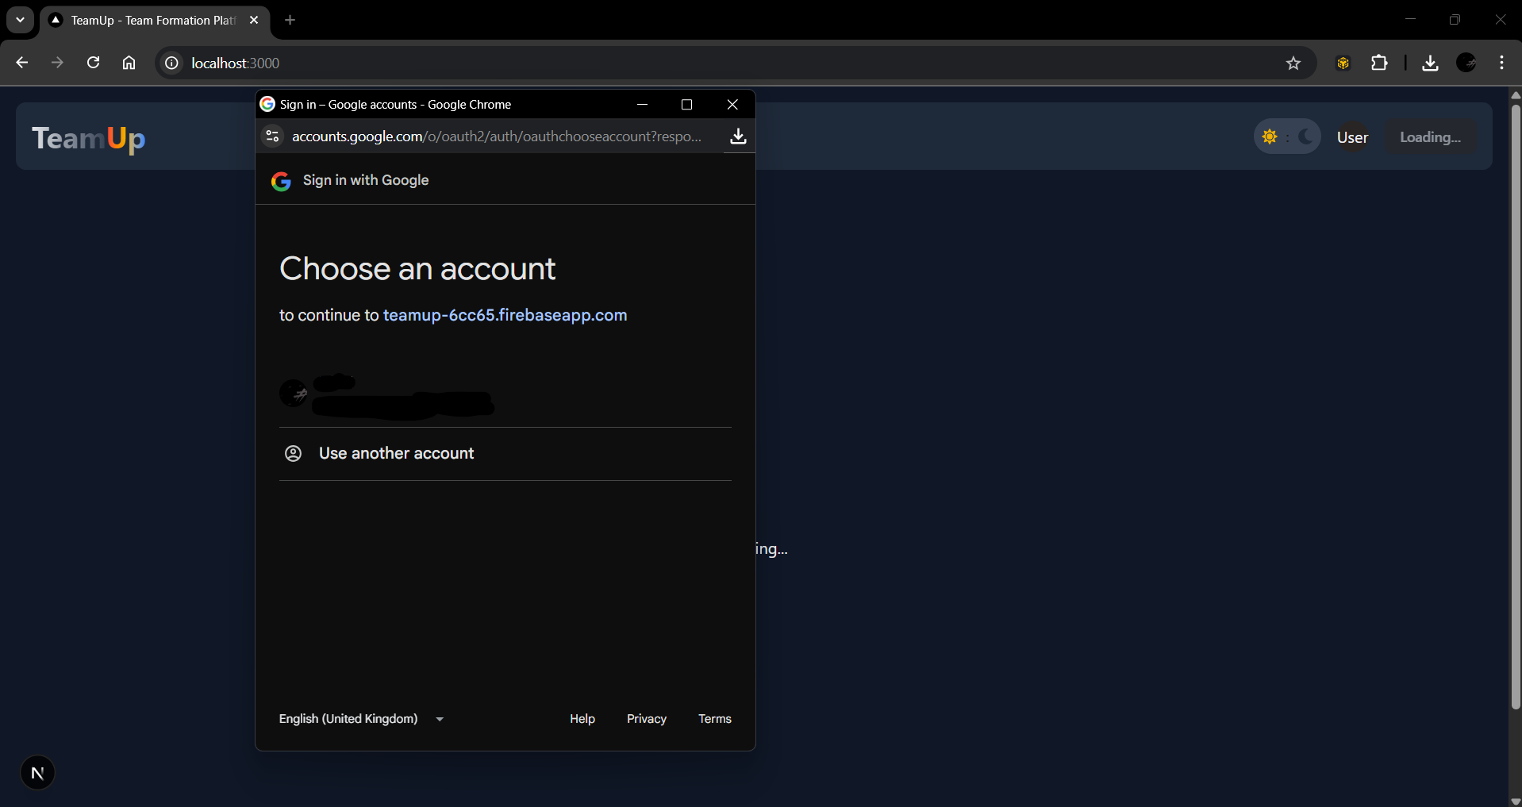
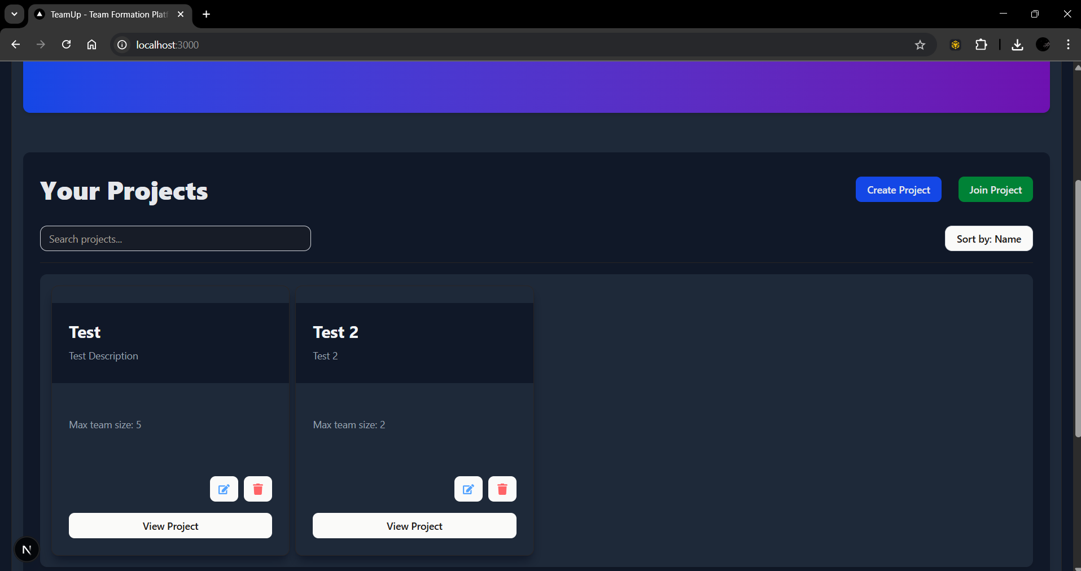
Technical Status:
- Application runs on local development server.
- Database stores all information correctly.
- User interface is clean and easy to use.
Technologies Used
Frontend:
- Next.js 15
- TypeScript
- Tailwind CSS
Backend:
- Firebase Authentication
- Firestore Database
- Real-time Updates
Why These Technologies:
- They are used by professional companies
- They handle many users at the same time
- They keep student information safe
- They make the application fast and reliable
- They allow the platform to grow if more students use it
Project Development Story
Original Plan: Started as a 3-person team project Challenge: Two teammates left due to semester eligibility requirements Adaptation: Continued as individual project Outcome: Working application that solves real student problems
This experience helped understand the team formation problem better and motivated creating a solution that prevents similar issues for other students.
Benefits for Students
For Project Creators:
- Easy way to describe project needs
- Can review and choose team members
- Clear overview of who wants to join
- Control over team size and composition
For Students Looking for Teams:
- Can see all available projects in one place
- Understand project requirements before joining
- Easy way to show interest in projects
- No pressure of direct messaging project owners
Future Possibilities
Potential Improvements:
- Integration with university course systems
- Advanced matching based on skills and preferences
- Analytics to show team formation patterns
- Mobile app for easier access
- Email notifications for important updates
Scalability: The platform can handle many students and projects at the same time. It could be used across different courses, departments, or even multiple universities.

